1.4

1.2
Revenue

1.0

0.8

0.6-
le6 Monthly Revenue Trend - 2011


InvoiceDate (Month)

250000

200000

150000
Value

100000

50000
Top 10 Countries by Revenue (Excluding United Kingdom)

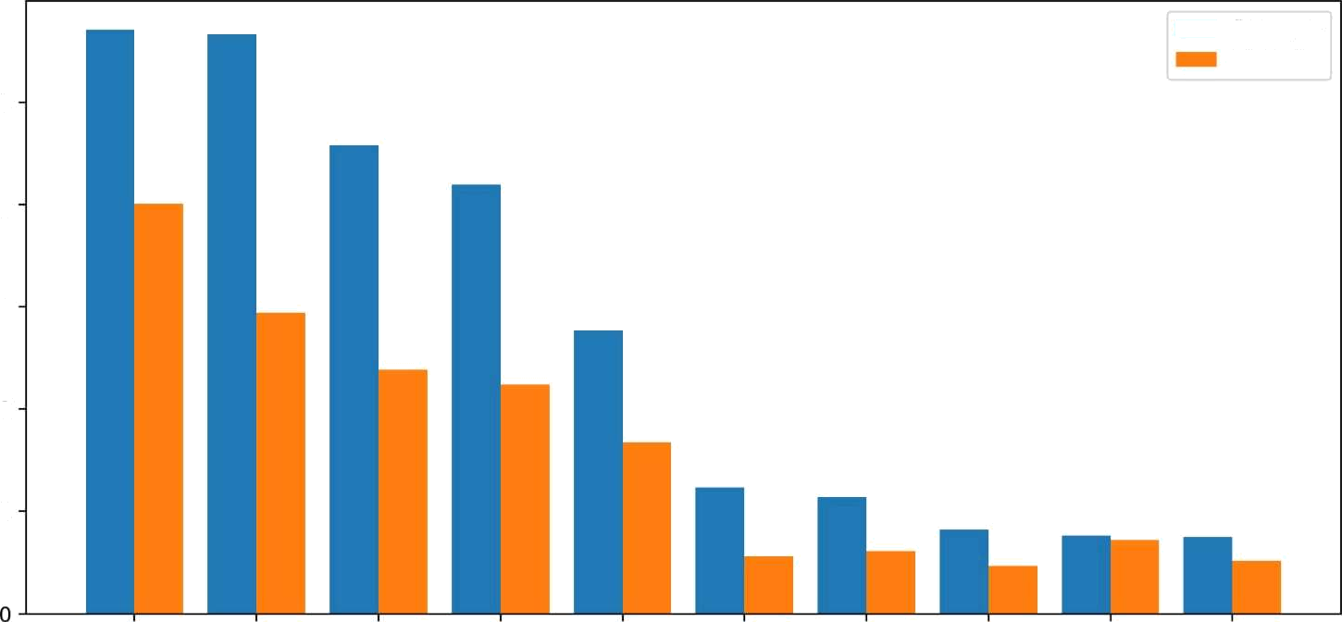




Country

Revenue
Quantity

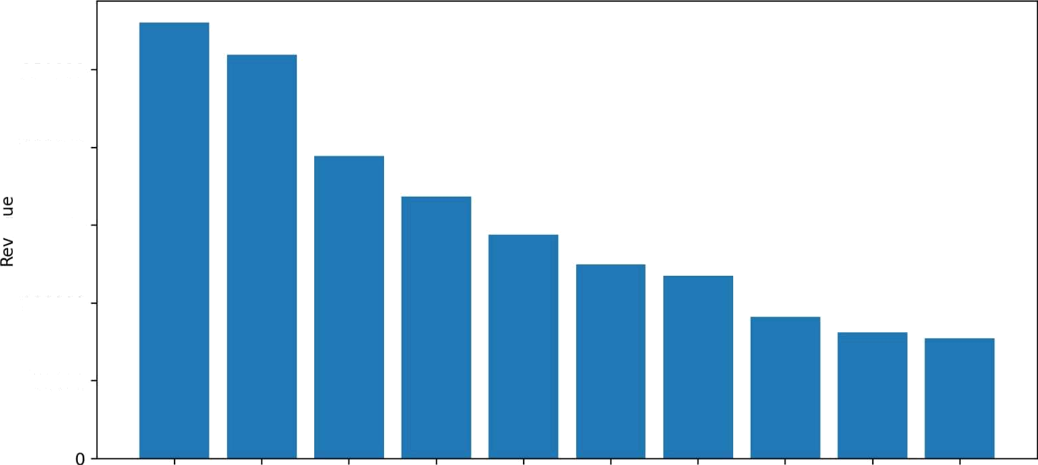
Top 10 Customers by Revenue
250000
200000
ø 150000
100000
50000

CustomerlD

World Demand Chart (Excluding UK)

y¢•û,2s\

Addl Garland -

2SQQ0 $0000 P5O0O 2 00

